SIMATS ENGINEERING

ASSESSMENT TOOL 1: Agent Design Assessment

COURSE NAME: | ARTIFICIAL INTELLIGENCE  AND EXPERT SYSTEMS | COURSE CODE: | MLA01

COURSE OUTCOME COVERED

CO1: Apply search algorithms and heuristic techniques to solve state-space search and optimization problems. (BTL 3)

Assessment Tool Weightage: 55 %

Total Marks: 50 Time: 60 Mins
No. of Questions: 1
Annexure A

Agent Design Assessment

Code of Conduct:

I K Sathwik Kumar (192425051) (Name / Reg No) certify that this submission is my original work and that I have adhered to the guidelines specified for this assessment. I understand that any violation of academic integrity rules will result in disciplinary action.

Signature of the student: K Sathwik Kumar

Question | Problem Understanding & AI Concept Identification | Dialogflow Agent Design & Implementation | Problem Formulation & Conversation Flow Design | Application of AI Techniques & Reasoning | Testing, Evaluation & Documentation | Total
Weightage | 20% | 30% | 20% | 20% | 10% | 100%
Q1

Signature of the Faculty Total Marks Awarded

Scenario
A university wants to develop an AI-based Student Support Assistant to provide instant responses to student queries related to course registration, timetable, examination schedules, attendance details, and campus services.
As an AI developer, design and implement a conversational agent using Dialogflow that can understand user requests, process intents, and provide appropriate responses.

Q. No. | Criteria to be evaluated | BL | Marks
1 | Problem Analysis and Agent Design: Analyze the student support problem and explain how Artificial Intelligence can solve the problem. Design the conversational agent by defining its objective, users, environment, inputs, outputs, and expected  performance measures. | BL3 | 10
2 | Dialogflow Agent Development: Create a Dialogflow agent by designing appropriate Intents, Entities, Training Phrases, Responses, and Contexts. Explain how the agent perceives user queries and generates responses. Provide screenshots of the implementation. | BL5 | 10
3 | Problem Formulation and Decision Flow: Represent the chatbot interaction as a problem-solving process by defining the initial state, user goal, possible actions, state transitions, and goal completion conditions. Draw the conversation flow diagram. | BL6 | 10
4 | Search Strategy Application: Analyze how search techniques used in AI problem solving can support conversational agents. Apply a suitable search approach (such as Breadth First Search or heuristic-based search) to model intent selection or dialogue navigation and justify your choice. | BL5 | 10
5 | Testing and Evaluation: Test the Dialogflow agent with different user queries. Evaluate accuracy, response quality, handling of unknown queries, and suggest improvements. | BL6 | 10

Scenario
AI-Based Student Support Assistant using Dialogflow
1. Problem Analysis and Agent Design (10 Marks)
Problem Analysis
Students often have questions about course registration, class timetables, examination schedules, attendance, and campus services. They usually depend on faculty members or the administration office, which can take time. An AI-based chatbot can provide instant answers and reduce the workload on staff.
Objective
To develop a chatbot that provides quick and accurate responses to student queries.
Users
- Students
- Faculty (optional)
- University Administration
Environment
- University Website
- Mobile Application
- Student Portal
Inputs
- Student questions in text
- Keywords such as attendance, exam, timetable, registration
Outputs
- Correct answers to student queries
- Helpful guidance and information
Performance Measures
- High response accuracy
- Fast response time
- User satisfaction
- Ability to handle multiple queries
2. Dialogflow Agent Development (10 Marks)
Agent Name
Student Support Assistant
Intents
- Welcome Intent
- Course Registration
- Timetable
- Examination Schedule
- Attendance
- Campus Services
- Goodbye Intent
- Default Fallback Intent
Entities
- @course
- @semester
- @department
- @date
Sample Training Phrases
Course Registration
- How can I register for courses?
- Register my subjects
- Course registration process
Timetable
- Show my timetable
- Class schedule
- Today's classes
Attendance
- What is my attendance?
- Attendance percentage
- Check attendance
Exam Schedule
- Exam timetable
- When is my exam?
- Semester exam date
Sample Responses
Course Registration
"Course registration is available through the student portal during the registration period."
Attendance
"Please log in to the student portal to view your attendance details."
Exam Schedule
"The examination schedule is available on the university website."
Context
- Welcome Context
- Student Services Context
Working
The chatbot receives the student's question, matches it with the correct intent using Dialogflow, extracts entities if available, and returns the appropriate response.
(Attach Dialogflow screenshots here.)
3. Problem Formulation and Conversation Flow (10 Marks)
Initial State
Student opens the chatbot.
Goal
Provide the correct information requested by the student.
Possible Actions
- Ask question
- Identify intent
- Search response
- Display answer

State Transition:
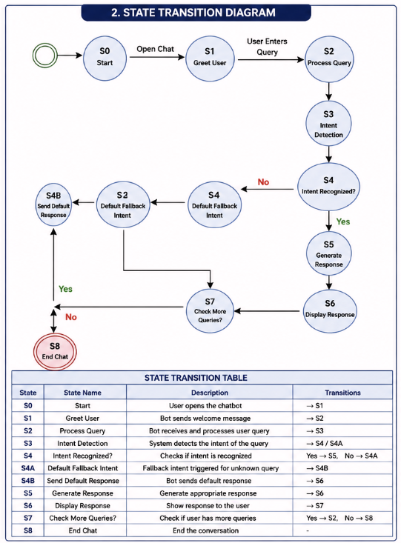

Goal Completion
The chatbot successfully answers the student's query.
Conversation Flow:

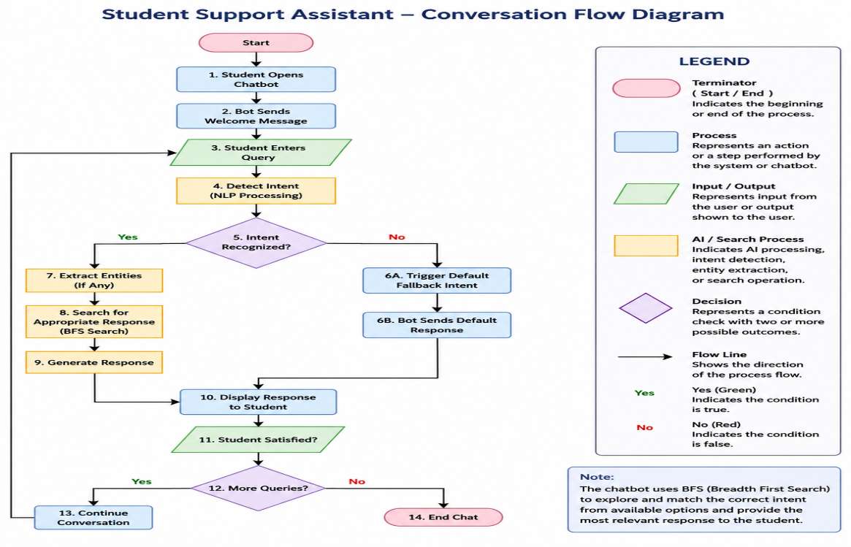

4. Search Strategy Application (10 Marks)
Search Technique Used
Breadth First Search (BFS)
Reason
BFS checks all possible intents level by level until it finds the correct matching intent. This ensures that the chatbot selects the most relevant response quickly.
Why BFS?
- Simple implementation
- Efficient for small and medium-sized chatbots
- Finds the correct intent without deep searching
- Improves response accuracy
5. Testing and Evaluation (10 Marks)
Test Query | Expected Result | Status
Show my timetable | Display timetable information | Passed
Check attendance | Attendance response | Passed
Exam schedule | Exam timetable response | Passed
Register course | Registration information | Passed
Hello | Welcome message | Passed
Random question | Default fallback response | Passed
Evaluation
- Accurate responses for common queries.
- Fast response time.
- Handles unknown questions using the Default Fallback Intent.
- Easy to use and user-friendly.
Suggested Improvements
- Add voice input support.
- Connect with the university database.
- Support multiple languages.
- Display student-specific attendance and results after login.
- Integrate with mobile applications.

Conclusion
The AI-based Student Support Assistant developed using Dialogflow provides quick and accurate responses to student queries related to registration, attendance, examinations, timetables, and campus services. It improves student support by reducing response time, minimizing staff workload, and providing 24/7 assistance. Future improvements such as database integration, multilingual support, and voice assistance can further enhance the chatbot's performance.

Evaluation Rubrics:

Criteria | Weightage (%) | Excellent (Full Marks) | Good | Average | Poor
Problem Understanding & AI Concept Identification | 20% | 10 – Clearly analyzes the student support problem, defines AI application, agent objective, users, environment, inputs, outputs, and performance measures with proper justification. | 7.5 – Identifies most components of the agent design with minor omissions. | 5 – Provides basic problem analysis with limited explanation of agent components. | 0–2.5 –  Incomplete understanding of problem and agent design.
Dialogflow Agent Design &  Implementation | 30% | 10 – Successfully creates a functional Dialogflow agent with appropriate intents, entities, training phrases, responses, contexts, and explains interaction flow with screenshots. | 7.5 – Develops major Dialogflow components with minor configuration errors. | 5 – Creates basic intents and responses with limited entity/context utilization. | 0–2.5 –  Incomplete or incorrect Dialogflow implementation  .
Problem Formulation & Conversation Flow Design | 20% | 10 – Clearly represents chatbot interaction using initial state, goal state, actions, state transitions, goal conditions, and a  well-designed conversation flow diagram. | 7.5 – Provides a structured flow with minor missing details. | 5 – Provides basic flow representation with limited explanation. | 0–2.5 – Poor or missing problem formulation and decision flow.
Application of AI Techniques & Reasoning | 20% | 10 – Correctly analyzes and applies suitable search strategies (BFS/heuristic search) for intent selection or dialogue navigation with strong justification. | 7.5 – Applies appropriate search strategy with reasonable explanation. | 5 – Provides basic understanding of search strategy application. | 0–2.5 – Unable to relate search concepts with conversational agent.
Testing, Evaluation & Documentation | 10% | 10 – Performs comprehensive testing using multiple user queries, evaluates accuracy, response quality, unknown query handling, and suggests meaningful improvements. | 7.5 – Performs adequate testing and provides evaluation with minor gaps. | 5 – Conducts limited testing with basic observations. | 0–2.5 –  Insufficient testing and evaluation.

